Amazon SQS (Simple Queue Service)
Amazon Simple Queue Service (Amazon SQS) offers a secure, durable, and available hosted queue that lets you integrate and decouple distributed software systems and components. Amazon SQS offers common constructs such as dead-letter queues and cost allocation tags. It provides a generic web services API that you can access using any programming language that the AWS SDK supports.

Let’s do a hands-on on AWS SQS
Build a real-time order processing system using:
- Amazon SQS
- AWS Lambda
Lambda should automatically process messages sent into SQS.

First let’s create a SQS Queue:
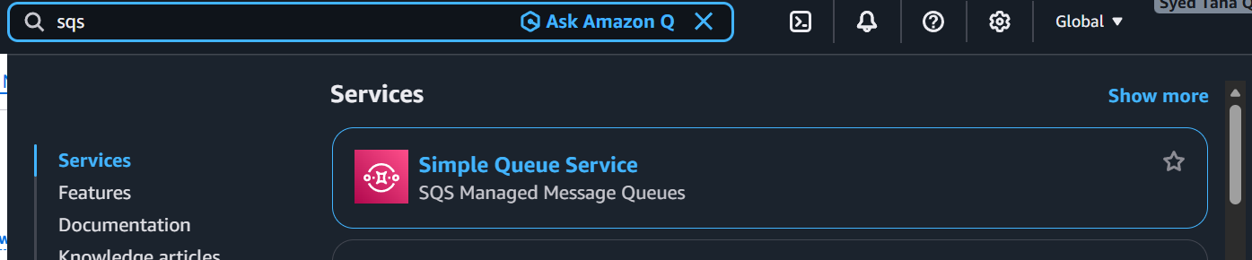

Click on create Queue
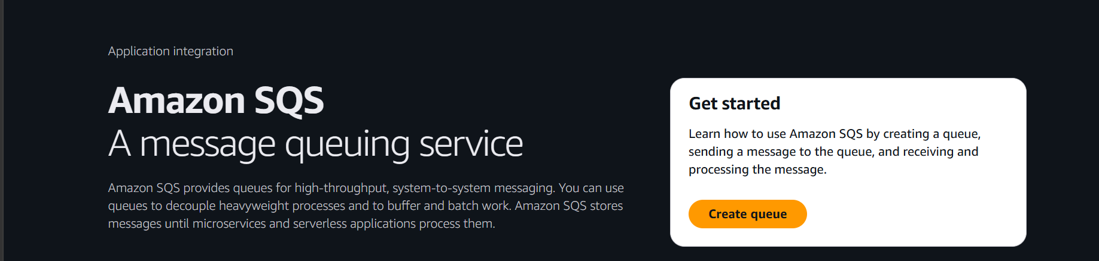
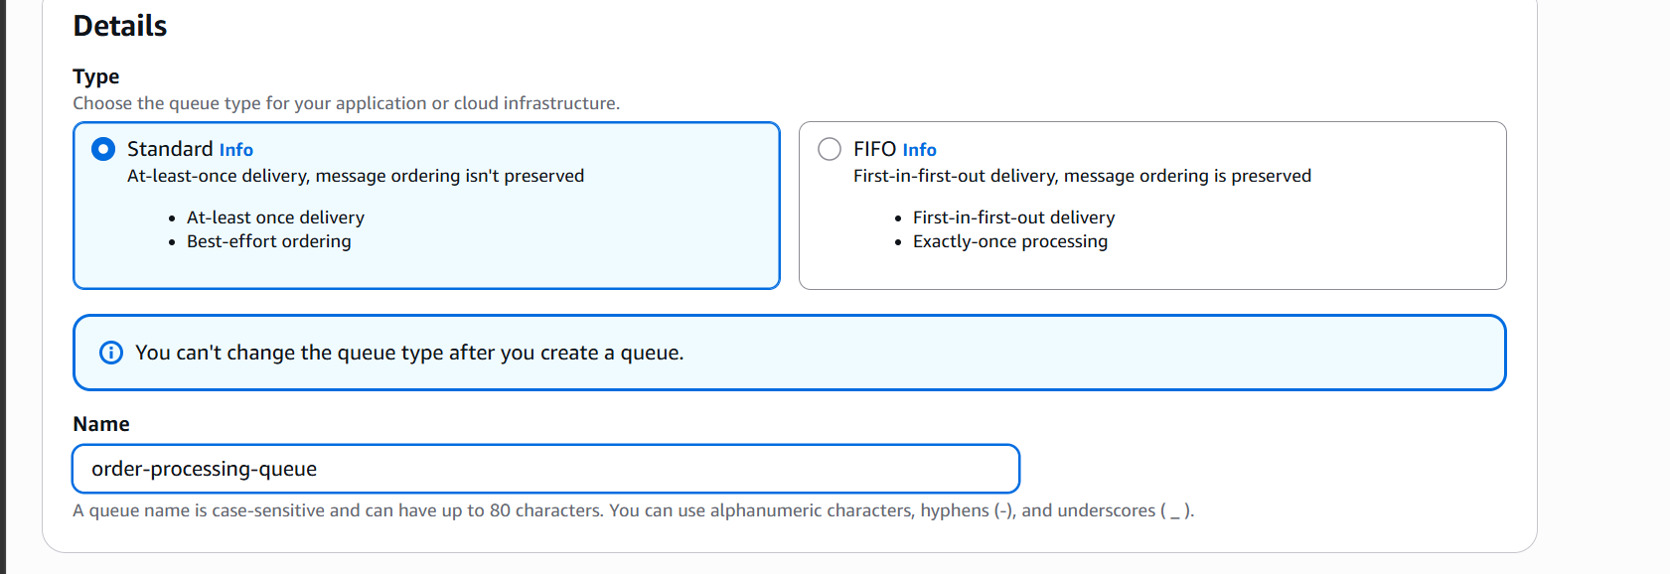

Leave everything default and create queue
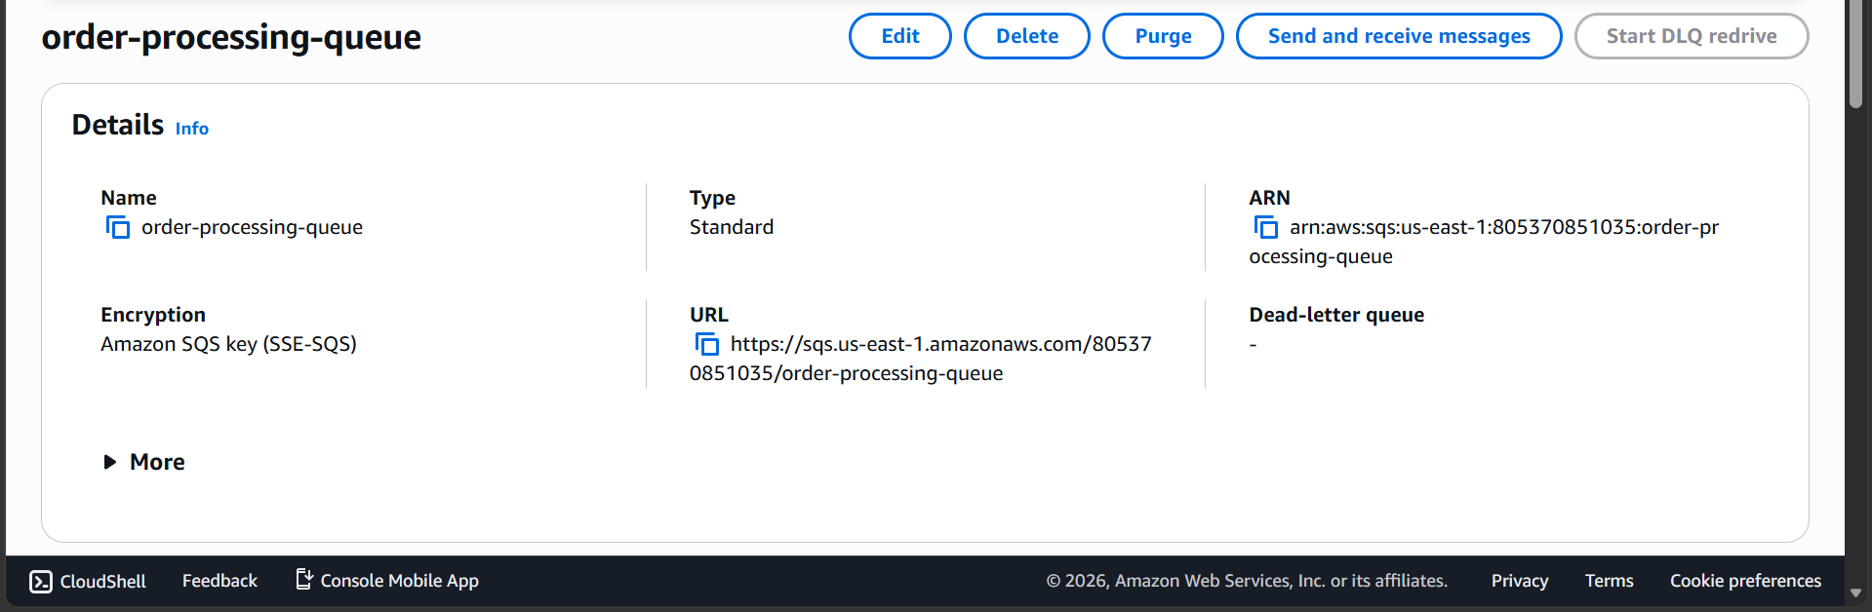

The SQS queue is created

Now let’s create a lambda function
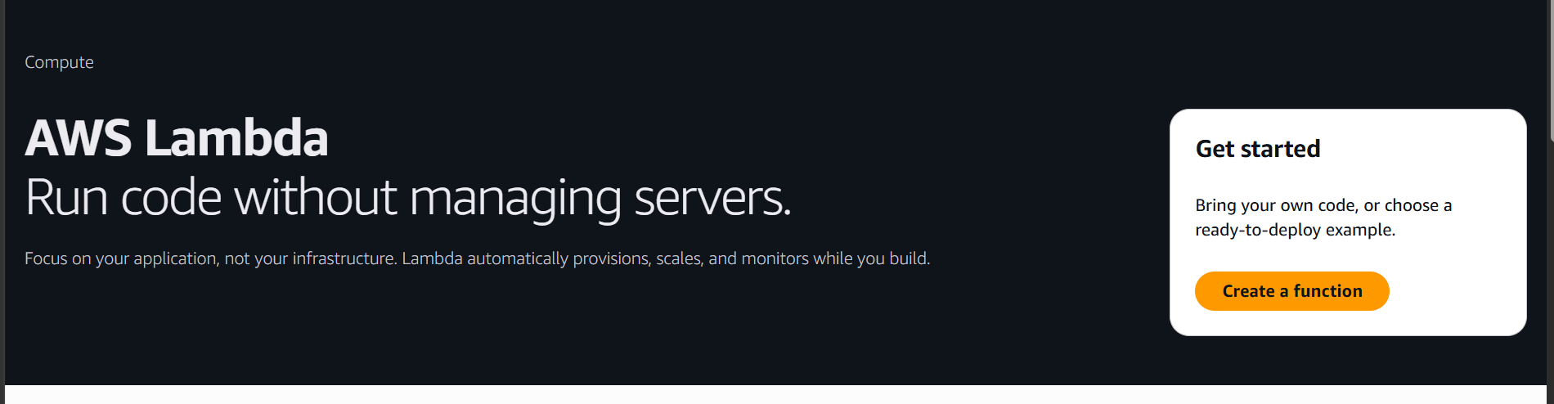
Search for lambda and click on create a function
Give function a name and select runtime

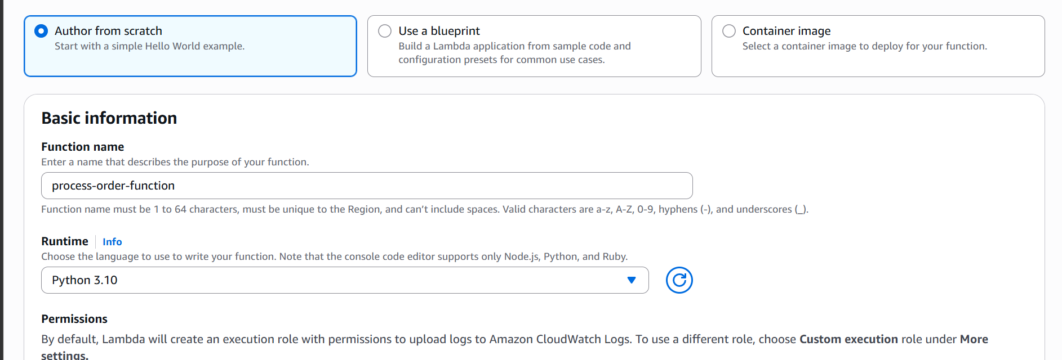
Now create function
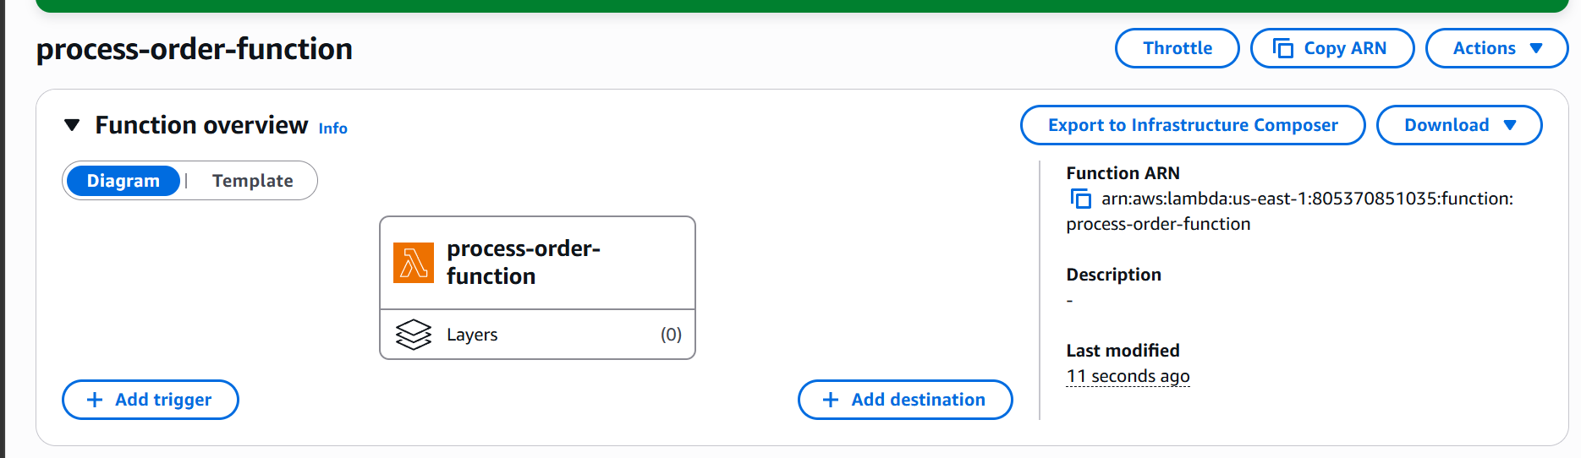

Lambda function is created
Add code to the function
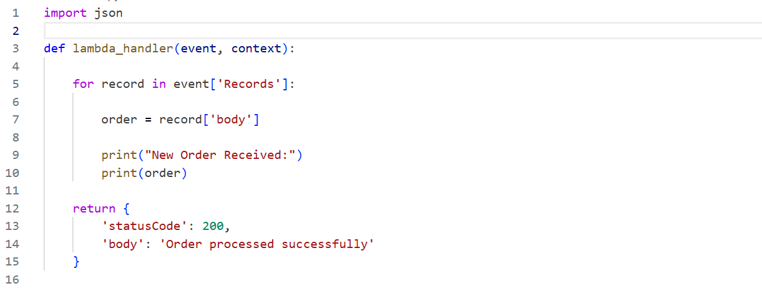
Now deploy the code
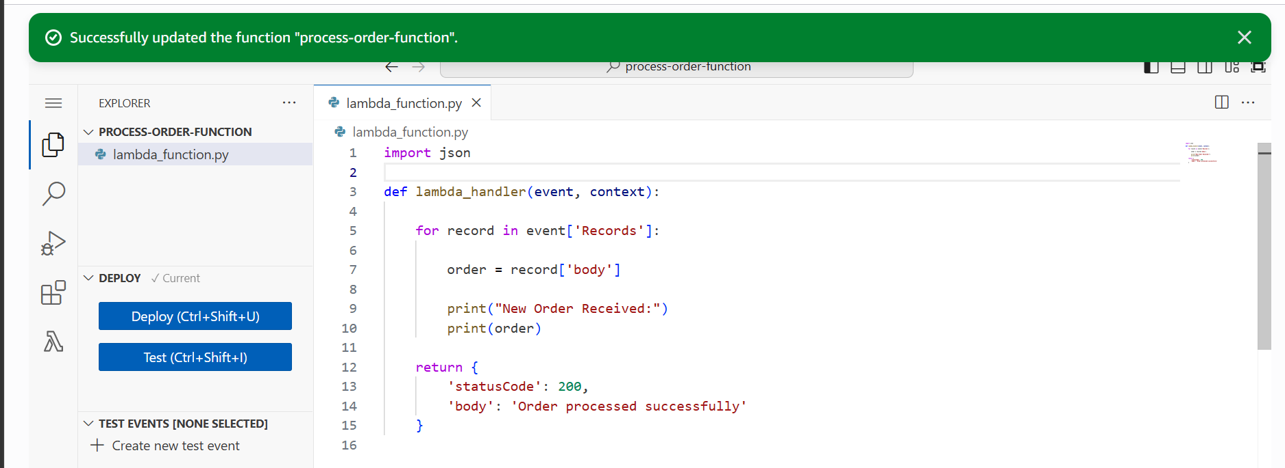
Code is deployed
This code will:
Receive messages from SQS
Print order details
Log output into CloudWatch.

Now let’s SQS trigger to lambda
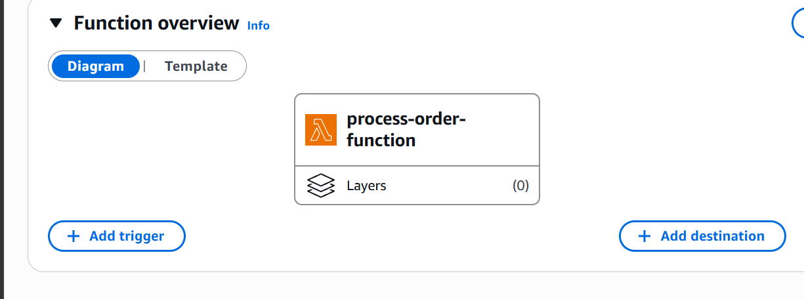
Click on add trigger and Select SQS queue
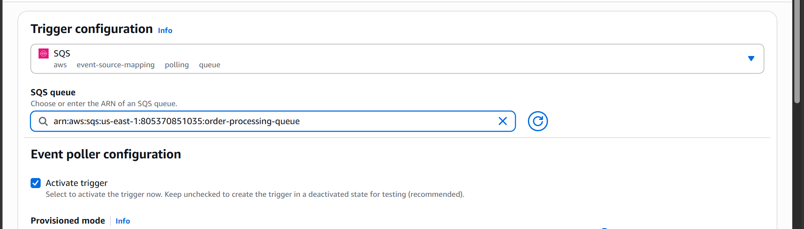

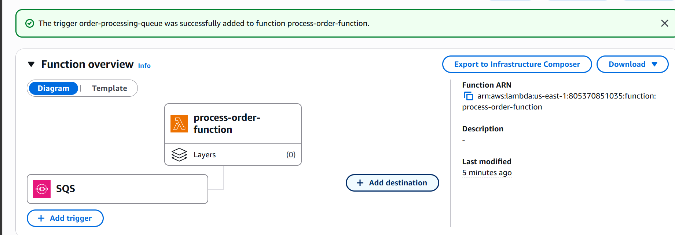

The trigger is now added
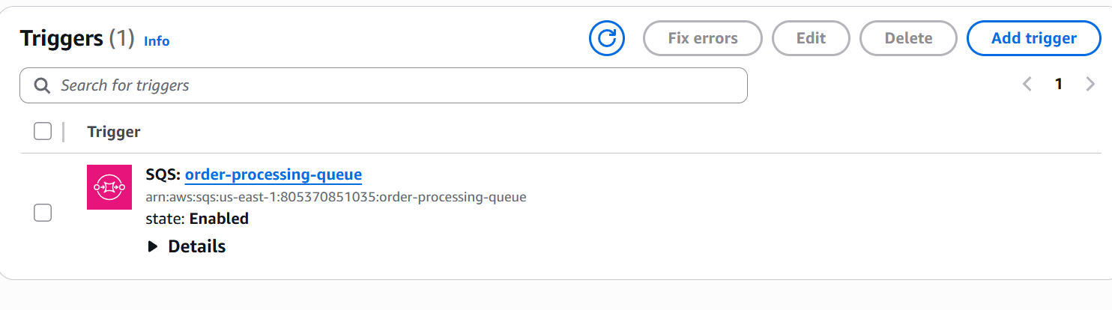
We can see that the trigger is enabled
Now lets send message to our SQS queue
Click on send and receive messages
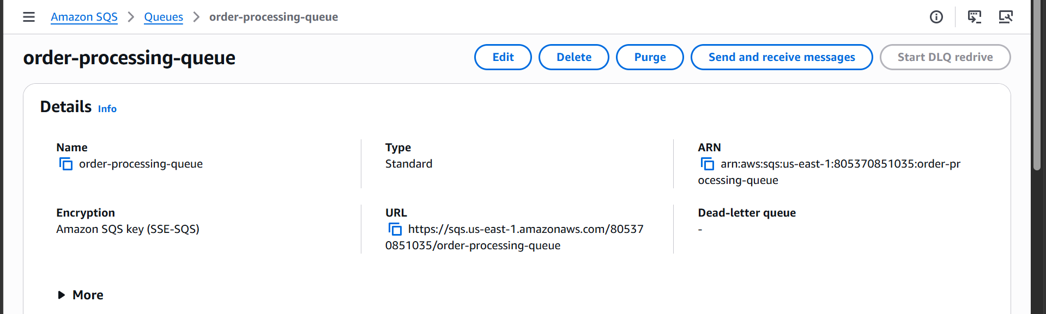
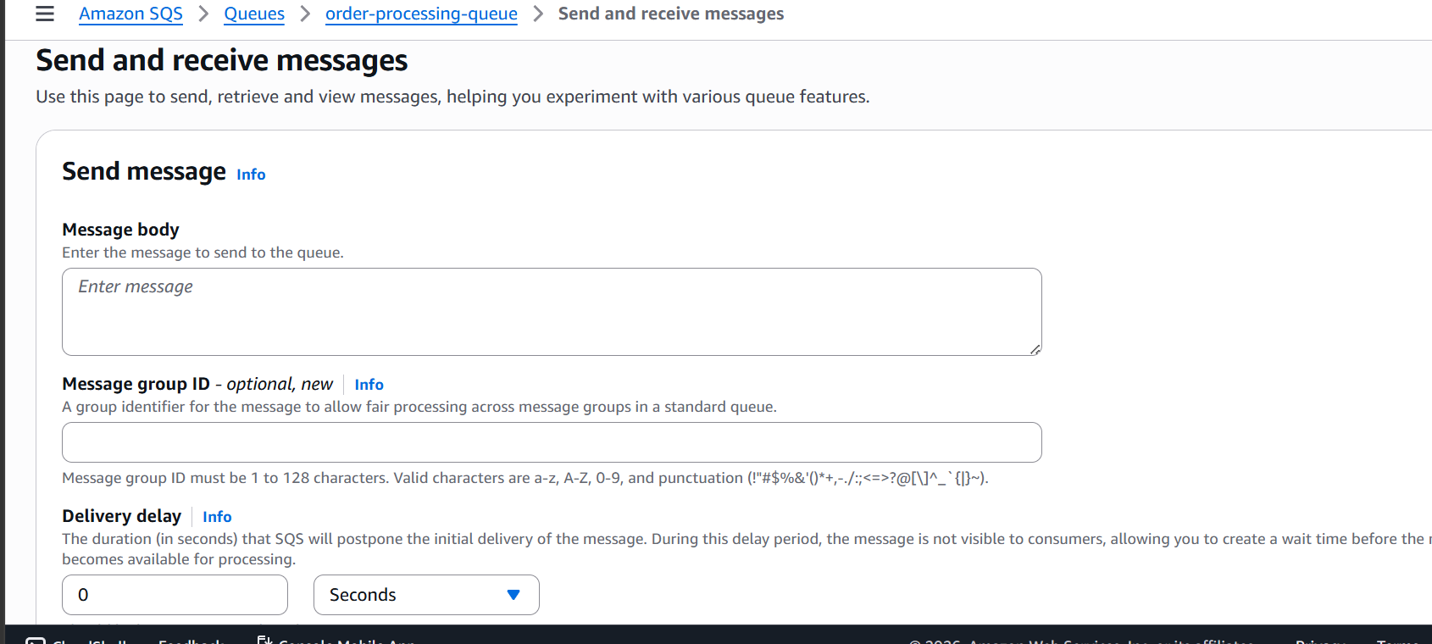

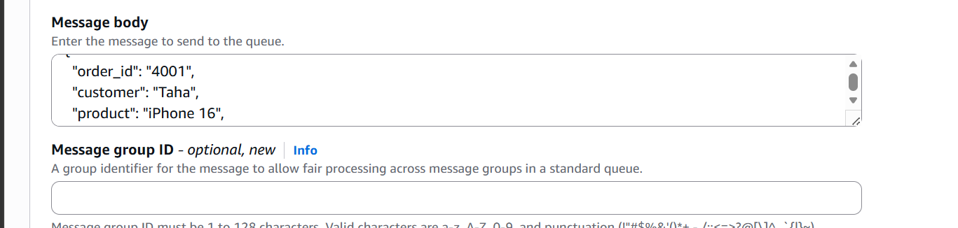
Add message in message body
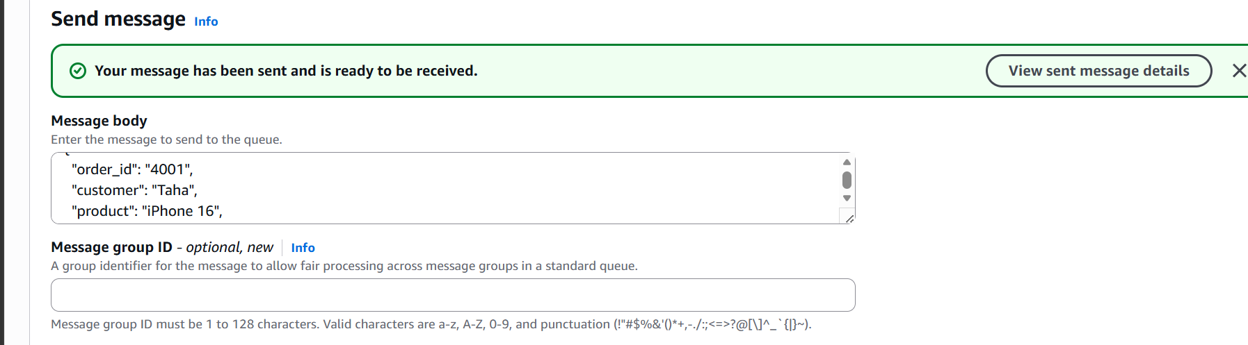
The message is now sent
Now lets go to the cloudwatch logs and validate the order message

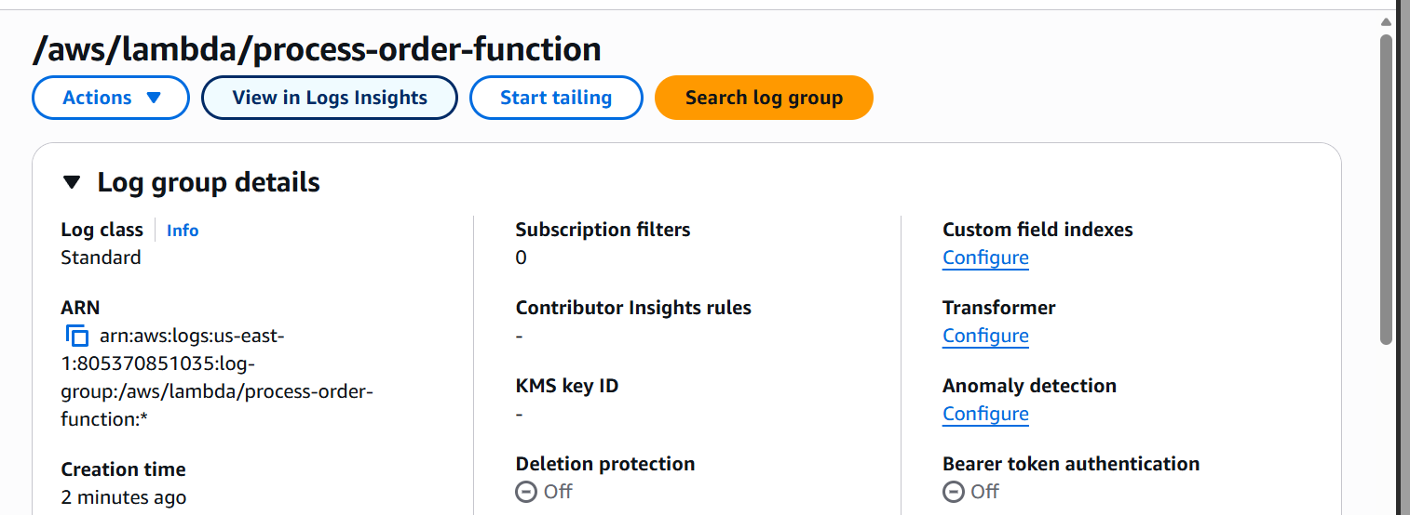

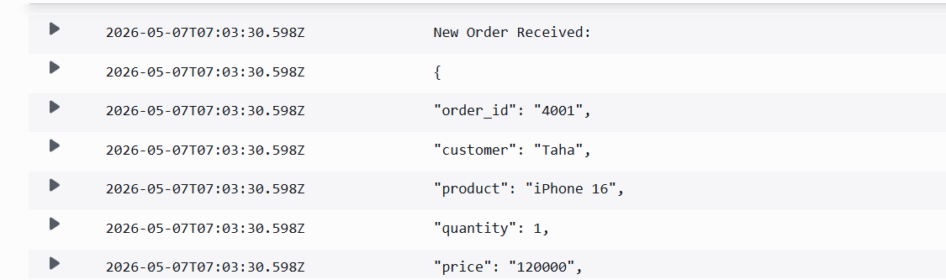

We can see the logs being genarated

We implemented a serverless event-driven order processing system using Amazon SQS and AWS Lambda. Messages representing customer orders were pushed into an SQS queue, and Lambda automatically processed those messages asynchronously. CloudWatch Logs were used for monitoring and troubleshooting, while IAM roles provided secure permissions for SQS access and logging.

